Operating Manual
ZionWorx V2.0 Worship Song Management System

Website: www.zionworx.org.uk
Software engineered by Christian J. Boxer
Acknowledgements:
Original document by Lau NK of KEC, Miri, Sarawak, Malaysia
Manual adopted and edited by William Ting, Miri for more generic use
Thanks to Edd Stonham for publishing this document.
Thanks to Christian and Tim for their continued effort to develop this free software.
More backgrounds picture can be downloaded from http://community.webshots.com/user/williamting. All ZionWorx users can use the backgrounds from this location freely. They are all my original work.
Glory be to God for His provision.
Table of Contents
ZionWorx – Songs Projection system Operating Guide 3
Operating the Notebook 4
Operating the LCD Projector 6
Operating ZionWorx Version 2.0 7
Frequently Asked Questions 11
In a nutshell 13
To prepare ZionWorx for worship celebration 13
LCD projector operator 14
Database maintenance (Add, update, delete songs) 15
Summary of Keyboard shortcut 16

ZionWorx – Songs Projection system
Operating Guide
Introduction
ZionWorx is a powerful, professional yet easy-to-use song display program, designed to meet the needs of churches that want to use multimedia in worship.
Many churches today, from all denominations, are experiencing the benefits that technology can bring when it is applied to worship in a sensitive and unobtrusive way - and this is where ZionWorx helps.
Unlike similar commercial worship software, ZionWorx is absolutely free.
The software is being developed in England, but now has a substantial user base throughout the world, and is currently being used by churches all over the world.
(The above introduction is adapted from www.zionworx.org.uk website)
Purpose of this document
This purpose of this document is intended to provide sufficient basic knowledge for Worship Leaders and LCD/Computer Operators to operate the ZionWorx Songs Projection System. It will describe the main components and the important features of the Notebook computer, the LCD Projector and the Zionworx 2.0 system but it is not meant to be a detailed user guide. This Guide will cover the following:
- How to Operate the Notebook
- How to Operate the LCD Projector
- How to Operate the ZionWorx 2.0 system
  - Create a worship Service list
  - Add new songs, delete songs, edit songs and arrange the verse sequence
  - Add in PowerPoint Slide Shows (for Sermons and Announcements)
  - Changing the background and controlling the external display.

For support of this software, please visit www.zionworx.org.uk and you are strongly encourage to participate in the forum. More tips are also available at this website.

Operating the Notebook
Figure 1: Acer TravelMate 420
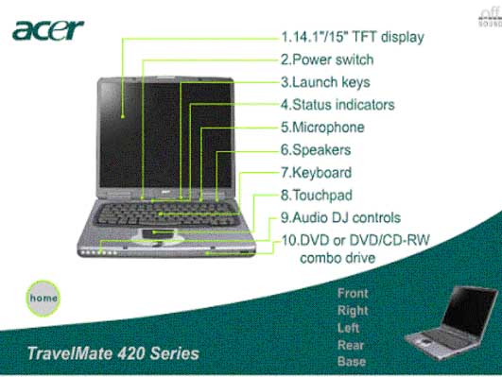
- Powering On and Off the Notebook
- ON button (Oval silver button just beneath the screen, No. 2 in the diagram above)
- To power off, click the start > Shutdown > Turn off computer sequence
- To shut down for a short while, use the start > Shutdown > Standby sequence
- Main Components of the Notebook
- CPU / Processor (Acer TravelMate 428C, Intel Pentium 4 processor, 2.4 GHz) with 256 MB RAM, running Microsoft Windows XP
- 1 Hard Disk (partitioned into C and F drive), total 40 GB
- 1 x VCD/DVD/CD RW Drive
- Battery pack (~ 2 hours running time)
- 3 USB ports (with 2 USB Handy Drive 128 MB)
- No Floppy Drive
- Mouse (optional) and Synaptic Touchpad (1 tap is like 1 left click on the mouse, 2 quick taps is like double click)
- Internal 56kbps modem – ready for Internet connection
- Systems Management
- Suggest C drive for Programs and F drive for Data, keep your private files on your own folder named appropriately (use Windows Explorer or My Computer)
- Common useful folders are already created, e.g. sermons, service lists, please use these; follow the naming standards
- Keep the Desktop clean and organised
- Regular backup important data (at least weekly or after major updates) to Handy Drive or CD-ROMs
- The database in the Notebook should be the Master and contain the complete songs list. Worship leaders need to advise the Church Secretary of any new songs they have created in the Handy Drive so they can be copied into the hard-disk.
- Handle the Notebook and LCD with care. Always keep/carry them in the original carrying bags (as these are specially designed to protect them.) Avoid exposing them in public as these are very expensive and much desired items.
- To connect the Notebook to the LCD Projector / external monitors, just connect the VGA cable (lying on the floor near the Notebook workstation) to the External Display port on the Notebook (see Figure 2 below).
- You can control the display on the LCD Projector / external monitors at will by using the Fn + F5 keys. This will toggle display on / off the LCD Projector / external monitors.

Figure 2: Back of Notebook
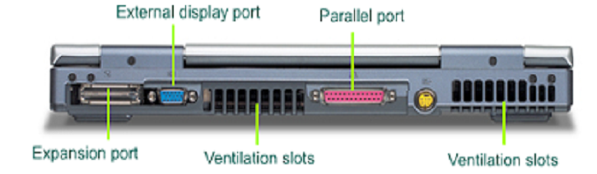

Operating the LCD Projector
Figure 3: Sony LCD Projector
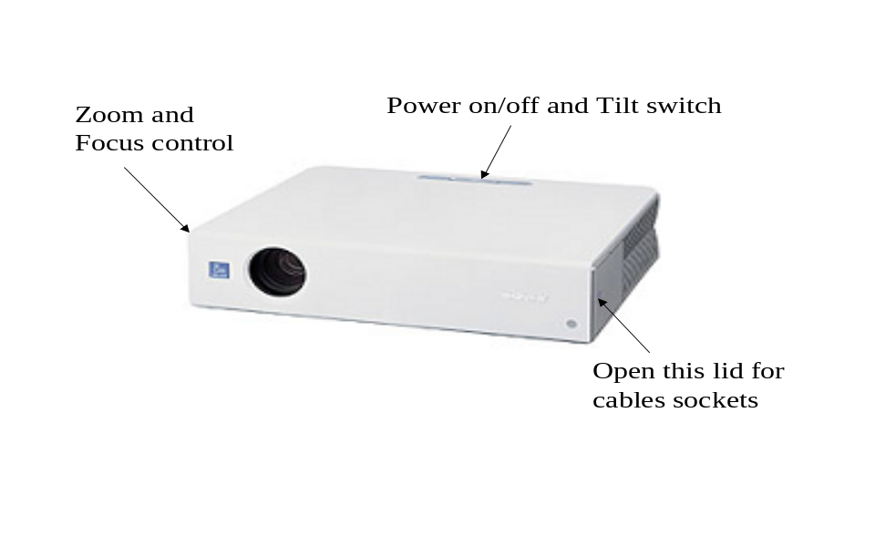
- Switching on/off the LCD Projector
- To switch on, press the ON/OFF button (left button on top of the projector)
- To switch off, press the ON/OFF button twice
- IMPORTANT - DO NOT SWITCH OFF AT THE POWER MAIN IMMEDITAELY AFTER USE!! It will shorten the life of the projector bulb by up to 70% and can cost up to US$500 to replace.
- Tilting the LCD (middle button on top of projector, left and right to go down and up respective, see the Up and Down arrows)
- Use the Zoom and Focus controls on the right of projector to adjust size and focus.
- To set up and connect the LCD Projector to the computer is easy. There are only 2 cables, the power cable and the VGA (video) cable. The socket points are on the side of the projector (see above). Please ensure the VGA cable is the right side up and fits the socket properly (don’t force it in, it should fit easily).

Operating ZionWorx Version 2.0
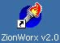
- Starting ZIONWORX
- On the desktop, look for the ZionWorx 2.0 shortcut icon. Move the mouse pointer over the icon and gently double click on the icon. Alternatively, locate the start button (on the bottom left side of screen) start > Programs > ZionWorx > ZionWorx
- ZionWorx 2.0 should now start and you will be presented with a ZionWorx main window as follows:
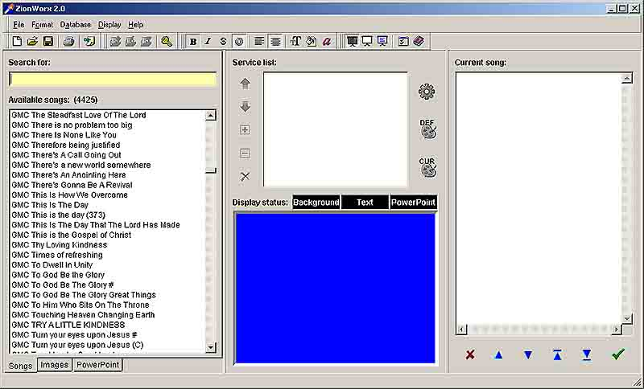
Figure 4: Zionworx 2.0 Main Screen
- ZionWorx Main Screen components
- Left column
  - Available songs (List of song titles). This is the complete list of song title available in the database. Double clicking on the song title here will cause the title to be transferred to the Service list window. Song title may be clicked and dragged using the mouse to the appropriate position in the Service list.
  - Search List. Typing any character will cause the listing in the Available songs window to scroll to any matching song title(s), eg, typing G will cause the Available songs window to scroll to songs starting with G. As more characters are entered, it will cause further zooming in to the matching title(s).
- Centre column
  - Service list. This window displays the sequence of songs to be used in a worship celebration. As songs were selected from the Available songs window, the song title will be listed in this window.
  - Display monitor. This window shows what is to be projected onto the external LCD projector.
- Current Song. This window shows the lyrics (verses) of the song currently being displayed on the projector. Verses in green font are those currently being projected; red font is next to be projected.
  - Tips:
    - Page Up or Page Down keyboard key may be used to position the next verse to be displayed.
    - Do not use the arrow keys
- ZionWorx Menu item
Figure 5: Zionworx Menu & Icons Descriptions
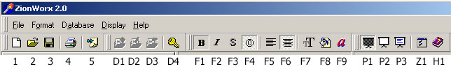
    - Start a new Service List
    - Open an existing service list
    - Save the current service list
    - Print option (Print current song lyrics; Service list; Available song titles)
    - Write quick note (messages/announcement)
D1-D4 – Database related icon: Add, edit, delete song, unlock database (F5, F6, F7, Ctrl-K)
F1-F9 – Display properties: font size, colour, backdrop colour, etc
P1 – Blank output on the projector (F10)
P2 – Display only the background image (F11)
P3 – Display background and lyrics on the projector (F12)
Z1 – Setting ZionWorx preferences. Need to restart ZionWorx in order to take effect.
H1 – On-line help
- Creating & saving a new Service list:
- Look for the songs in the database. Type the first letter of the song title will display all the songs beginning with the letter. You can search for the song by entering the first few word(s) of the title in the Search for field.
- Point to the song selected and double click on the song to place it into your Service list (middle column). You can also drag and drop or simply hit enter on the highlighted title.
- If the song is not there then add in the new song (see Section 4 below), and repeat the above
- To edit the song go to Section 5.
- To re-order the Service list entry, use the Up and Down button; to delete the song, click the X button.
- It is important to save the Service list regularly. To do this, use either the File > Save or click the Diskette button (3 in Figure 5). If saving for the first time, you need to key in a name for the Service list. Please save in the Service list folder and use the standard naming convention - yymmdd name e.g. 041114 AM.
- You may save the Service list to the removable handy drive if you are not using the church computer. Remember to copy the service list to the church computer before worship celebration. Note: service list has the file extension bin.
- You may exit ZionWorx and shut down the computer at any time and come back later to continue your work. But first ensure you have saved the Service list. To return to where you have left off, use the File > Open menu item or click icon 2 above.
- Adding songs to the database
- To add a new song to the database, you need to unlock the database with a password. To enter the password, click the Key button (icon D4) or use the Database > Unlock menu items. Ask Pastor or the Church Secretary for the password. Note: Do NOT change the password!
- Next click on the Add New Song button (icon D1 or press F5). Add song window is now displayed.
- Enter the Title and the Lyrics of the song.
- When finished, click ok and the new song is now added to the database.
- You can merge songs from other ZIONWORX database into our own database using the Database > Import function – but remember that the database must first be unlocked.
- Editing a song in the database
- Click the appropriate song title in Available Songs.
- Click D2, or press F6 or Database > Edit Song menu item.
- Edit Song window is now displayed with the song details and editing may now take place.
- Delete a song from the database.
- Click on the song title and click the Delete (X) button.
Important note: You must exit ZionWorx in order to save what you have updated (add, edit, delete) in the song database. Failing to exit properly will cause all your updates to be lost!
- Controlling the external display on the LCD projector and the monitors
- Remember the LCD projector shows only what is on the display monitor (center column bottom screen). To display on the projector, you must first click the show background and text (P3).
- Then double click on the song in the Service list. This will send the song immediately to the external display. However, if you find that the projector is still blank, try to press F12 or click and click on the green tick
- Tapping the spacebar or hitting Enter will automatically go the next verse. To skip a verse or jump to another verse, use the Pg Dn and Pg Up key. The verse to be projected next will be highlighted in red font. Alternatively use the Up or Down arrow buttons on the bottom of the right column screen.
- To go to the next song press F4 and to go to the previous song press F3. Hint: remember 4 is to go 4ward.
- It may be useful to repeat the chorus in a song in between verse so that it is easier for the Operator to operate. He/she only needs to hit Enter or tap the spacebar to play the song.
- It is important not to display too many lines on the projector at any one time. A logical break will be a verse or a chorus. But exceeding 8 lines is discouraged. To break it up, insert a blank line.
- To temporary project a blank/black screen, click the Fade to black icon (P1).
- To display just the background without the song, hit the Show background only icon (P2).
- To display both text and background again, hit the Show Background and text icon (12).
- To change the background of the display
- Click the Images tab on the bottom left of the screen
- Click the Down arrow button under Category. Select any of the various background pattern or images (photos) by double clicking on the selected background.
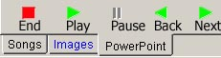
- To show PowerPoint slides
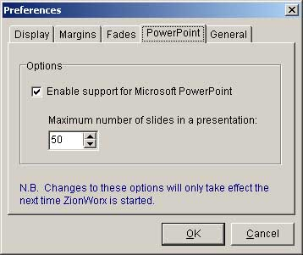
Note: If you do not see PowerPoint tab below Available songs window, you must first enable it. Click the Set preferences button or hit Ctrl-P, click PowerPoint tab and enable Support for Microsoft PowerPoint. Shutdown ZionWorx and restart.
- First click on the PowerPoint tab .
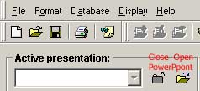
- Then go to the top right of the screen and under Active Presentation, click on the Open-presentation button (right button). Load the presentation.
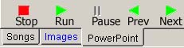
- To go forth and back of the slide, use the Green arrow. As a tip, you can adjust the PowerPoint preview window so you can see more previews slide by dragging and pulling the left column window bar.
- When finished with PowerPoint, click the Stop (square) button to return to ZionWorx (IMPORTANT - else ZionWorx cannot continue).
- As a recommendation, PowerPoint slide’s fonts size must be at least size 24 – else the congregation will not be able to see the wordings from the back of the worship hall.
- To insert a quick note - Sometime you may want to insert a quick note for the audience. Do this using the Write-quick-note button. This can used to insert Bible passage or make an announcement.

Frequently Asked Questions
Q: Can a Worship Leader choose not to use the system?
A: Worship Leaders have to use the system as the old OHP system will no longer be maintained. Worship leaders are strongly encouraged to learn and use the system themselves as the wide range of songs in the database complete with the lyrics and the easy search of the songs will allow them to bring the most appropriate songs to complement the message of the day. It is a ministry for us to help the church to worship the Almighty God, our Lord Jesus. Worship leaders can prepare their songs (service) list before hand and pass this to the Church Secretary to prepare the system for them. If they choose to do this, then they must pass the list to the Church Secretary before Friday lunchtime at the latest. Any new song to be included which is not in the database, must be provided in hardcopy or softcopy form. In fact, Worship leaders can do their own Service list in about 15 minutes (maybe less) before the practice if they have planned and select their songs before hand. Pastor or the Church Secretary will make the Notebook and LCD projector available for the practice on Saturday afternoon.

Q: Can I install the system on my home PC?
A: Yes, you can. In fact you do not have to install the system at all. The Notebook came with a Handy Drive and the ZIONWORX system with the songs database installed. If your home PC support USB storage device (works with Windows ME and XP), then you can just run the system from there. Use My Computer or Windows Explorer to open the Handy drive folders. The drive will be marked as “Removable Drive”. The ZIONWORX program (Zionworx) is located in the \Zionworx 2.0 Full Install\program files\Zionworx\ directory. Double click on the Zionworx icon or application file and the system will fire up. You can save the Service list you created in the Service list folder. Just bring the Handy Drive to Church – that’s all. If you can’t write to the Handy Drive, check the Write-protect switch on the Handy drive. You can install the system on your PC if you like. Just run the Setup program in the \Zionworx 2.0 Full Install\ directory. Remember to register ZionWorx. Refer to www.zionworx.org.uk.

Q: What happen if the Notebook or the LCD Projector breaks down?
A: If the Notebook breaks down, the fallback is to use Pastor’s or one of the church member’s notebooks. It is installed in a number of PCs and notebooks. They however will likely not be able to support dual screen. If the LCD projector breaks down, then it is a problem!!! Suggestion is for the Church to buy a spare bulb and learn how to change the bulb. Worst case we will use the old OHP system!

Q: Who do we call if we have a problem?
A: For problem in using the system, you may call brother ????? or ?????. For technical problem with the notebook and the monitors (not the LCD), call ????????. The notebook is covered by a 3-year warranty. For problem with the LCD projector, call brother ?????????.

Q: Do you have any tips to tell us?
A: There are a few useful tips for you to know: As you use the system more I am sure you will learn more.
- Fist of all, the Notebook is equipped with a “Dual View” capability. This allows ZionWorx to show a different screen on the operator computer from the external LCD projector/monitors. At times you may “lose” this Dual View capability – this happens when you go into PowerPoint slide show and run it native i.e. not under ZionWorx (as explained above). In the event you lose the Dual Screen capability, you need to run the Control Panel application and change the Display back to 2 (dual) screen. To do this minimize all application and go to the desktop. Right click and select Properties > Setting. Click (tick) the “2” screen and click the “Extend my Windows desktop into the monitor” button. Finally click Apply to effect the changes and you are back in business.
- There are some “shortcut” keyboard actions which can make life very much faster for you. These are especially useful when you copy songs from the Song Book Word document into the ZionWorx database. Some of these shortcuts are:
  - ctrl + c - to copy a selected section of texts or picture
  - ctrl + v - to paste into the current cursor position
  - ctrl + x - to delete a selected text or picture and stored in the “clipboard” (memory) and this can be paste (Ctrl + v) into somewhere else
  - alt + tab - to jump to another application e.g. Word currently running in your computer.
- Sometimes an application may “hang” i.e. cannot response any more. To “terminate” the application, use the Task Manager. This is available by right clicking the bottom right corner of the screen (where the clock is). Task Manager will pop up. Follow the dialogue and terminate the “hung” application.

In a nutshell

To prepare ZionWorx for worship celebration
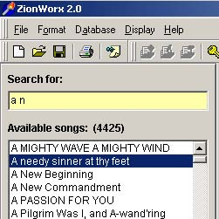
- Prepare your list of song for the worship celebration
- Switch on the computer.
- Start ZionWorx from the desktop.
- From the ZionWorx, find the song by entering the name in the Search for field
- When song is found, double click on the title to append it to the service list; or drag and drop it to the appropriate position in the service list.
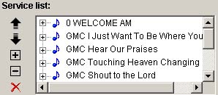
- Ensure that the order of the songs in the service list is correct. Otherwise, move them around using the respective up/down arrows buttons.
- On completion, save the service list using a standard naming convention with the prefix yymmdd. The suffix could be some meaning code, eg, AM, PM, etc
- If desire, proceed to add the background image. But remember to save the service list often. More background pictures can be obtained from http://community.webshots.com/user/williamting. To download background image, click on the desire thumbnail image. When a bigger picture is display, point mouse over the picture and right button click and select Save picture as when the pop up menu is being displayed. Remember to save it to an appropriate directory under Backgrounds directory.
Tips: Format the lyrics so that the screen is not congested. Ideally, there should be no more than 6 lines of lyrics at any one time.
Ideally, use outline text for formatting as the text will show very well on any background.
Text should be sufficiently large so that congregation can see clearly at the back.
If background is use, do not use one that is very complicated as it can be very distracting and concentration of the congregation may be lost.

LCD projector operator
- Switch on the projector and then the computer
- Start ZionWorx from the desktop.
- Open the saved service list. The name should be of the format of today’s date, eg, 041114 (year 2004, Nov 14). When opened, the list of songs will now be displayed and the songs should be displayed in the proper order.
- To project the first song, double click on the first song entry in the service list window.
- The lyrics/verses should now be displayed in the current song window
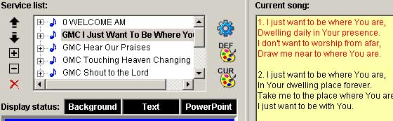

    - “Switch” on the projector by clicking the icon. Or press F12.
    - To display the first verse, click the green tick..
    - To ensure that the next verse is correctly projected, use either the Page Up; Page Down key on the keyboard; or or button until the verse is selected and shown in red.
    - Hit the spacebar key, or the green tick. or the Enter key to project the verse. The system will automatically indicate the next verse to be projected in red. If this is incorrect, repeat step 8 above.
    - To move to the next song, double click on the song title in the service list. The first verse will be displayed automatically. Repeat step 8-9 above as appropriate.
Tips: To temporary blank the projector, click or press F10; to display only the background, click or press F11.
Note: When worship is over, shutdown the computer, switch off the projector using the switch on the projector. Wait till the flashing light on the projector stop blinking. Only then the power switch can be switched off. Failure to follow this will cause premature aging of the bulb that is very expensive to replace.

Database maintenance (Add, update, delete songs)
- Ensure that the database is unlocked by clicking . The password is password.
- To edit a song, search for the title, and click on the title in Available Songs.
- Press F6 or click to go into edit mode.
- To add a song, press F5 or click
- To delete a song, select the song and press F7 or click
- Exit ZionWorx on completion to save. Failure to exit properly will cause all the editing to be lost.

Summary of Keyboard shortcut
(Adopted from ZionWorx V2.0 Help File)
ZionWorx provides a number of keyboard shortcuts for commonly used operations. Below is a list of currently supported shortcuts, sorted into related categories.
Text Formatting
Ctrl+B | Bold text on/off
Ctrl+I | Italic text on/off
Ctrl+S | Shadow text on/off
Ctrl+O | Outline text on/off
Ctrl+L | Left align text
Ctrl+E | Centre align text
Ctrl+T | Display font options
Ctrl+F | Select background fill colour
Ctrl+A | Set text effect options

Fade Controls
F10 | Fade to black
F11 | Show background only
F12 | Show background and text

Database Operations
Ctrl+K | Lock/unlock database
F5 | Add song
F6 | Edit song
F7 | Delete song

General
Ctrl+P | Set preferences
F1 | View presentation screen
F3 | Load previous song
F4 | Load next song
Alt+F4 | Exit ZionWorx

Note: More information may be obtained from the ZionWorx online help that may be activated from the Help button. If this fails, look for zionworx.chm in the ZionWorx directory and double click on it to open.

